Python Programming

Experiment Report

Name DIO STANIA ADINATA
Student Number
Major Software Engineering
Class 2023

2022

Experiment 3

- Experimental Purpose
Experiment 3 aims to deepen the understanding of Python programming through the following objectives:
  - Learn how to use string concatenation to combine strings.
  - Master the usage of lists in Python by implementing operations such as storing user input and calculating statistics.
  - Master the usage of tuples in Python by accessing elements using indexing.
- Experiment Content
  - Objective1: Input() function
    - Design thought
I plan to create a Python program that will ask the user to enter their first name and last name using the input() function. The two strings will be concatenated with a space " " in between them because if not the full name will become one word, and the full name will be displayed using the format "My name is ...".
    - Source Code
#input()
first_name = input("Your first name: ") last_name = input("Your last name: ")

#output()
full_name = first_name + " " + last_name print("My name is", full_name)
    - Experiment Result

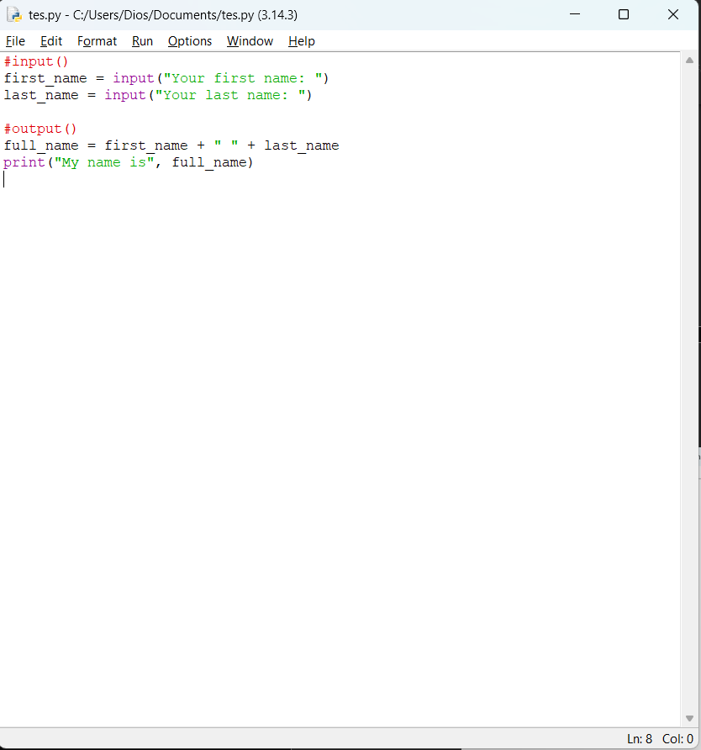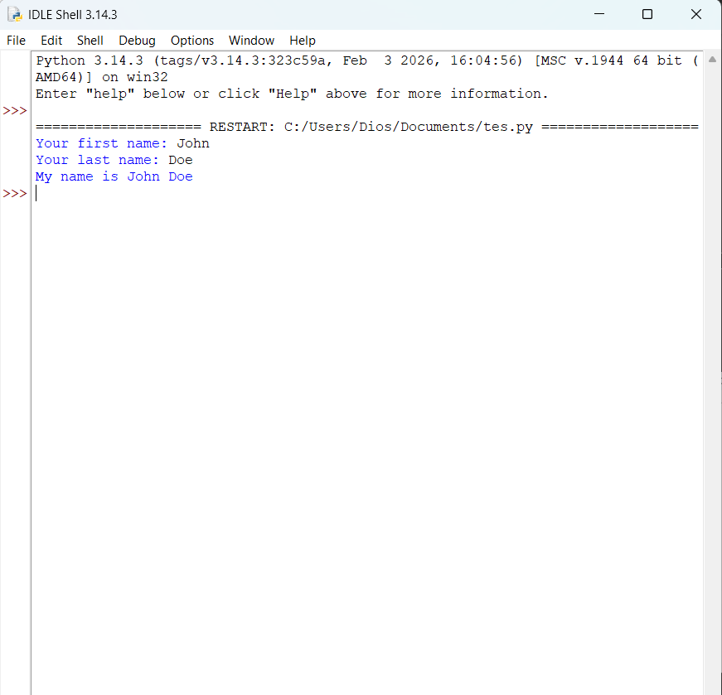

  - Objective2: Average Value Calculation

    - Design thought
I plan to create a a predefined list list1 = [12, 46, 8, 52]. The mean value is calculated by summing all elements and dividing by the number of elements. The result is printed. But before the result is shown, I planned to make the program show the total and count value first.
    - Source Code
list1 = [12, 46, 8, 52]
total = sum(list1)
print("the total value of the list is:", total) count = len(list1)
print("the count value of the list is:", count) mean = total / count
print(total, "/", count, "=", mean)
print("The mean value is:", mean)
    - Experiment Result

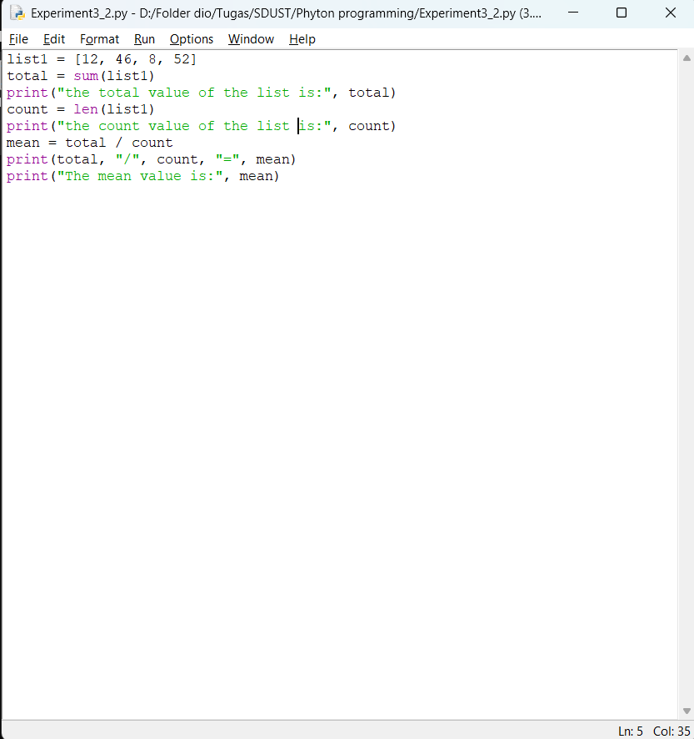
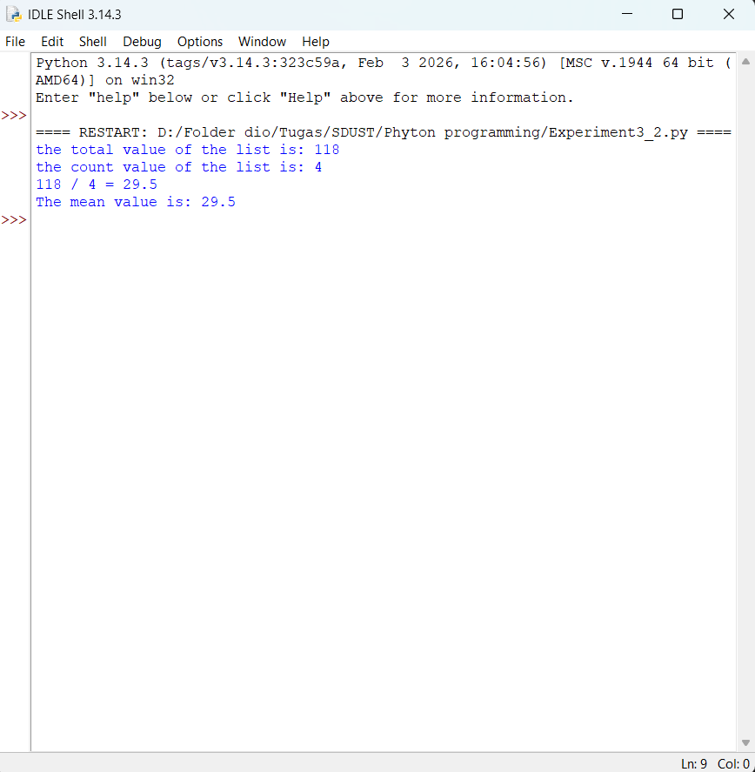

  - Objective3: Series of 20 Numbers
    - Design thought
I plan to create a Python program that asks the user to enter 20 numbers one by one. Each number is stored in a list. After all inputs are collected, the program calculates and displays with following order:
- The lowest number in the list (min())
- The highest number in the list (max())
- The total of all numbers (sum())
- The average of the numbers (sum() / len())
    - Source Code
numbers = []

#input
print("Please enter 20 numbers:") for i in range(20):
num = float(input(f"Enter number {i+1}: ")) numbers.append(num)

lowest = min(numbers) highest = max(numbers) total = sum(numbers)
average = total / len(numbers)

#output
print("\n--- Results ---") print("Lowest number:", lowest) print("Highest number:", highest) print("Total of numbers:", total)
print("Average of numbers:", average)
    - Experiment Result

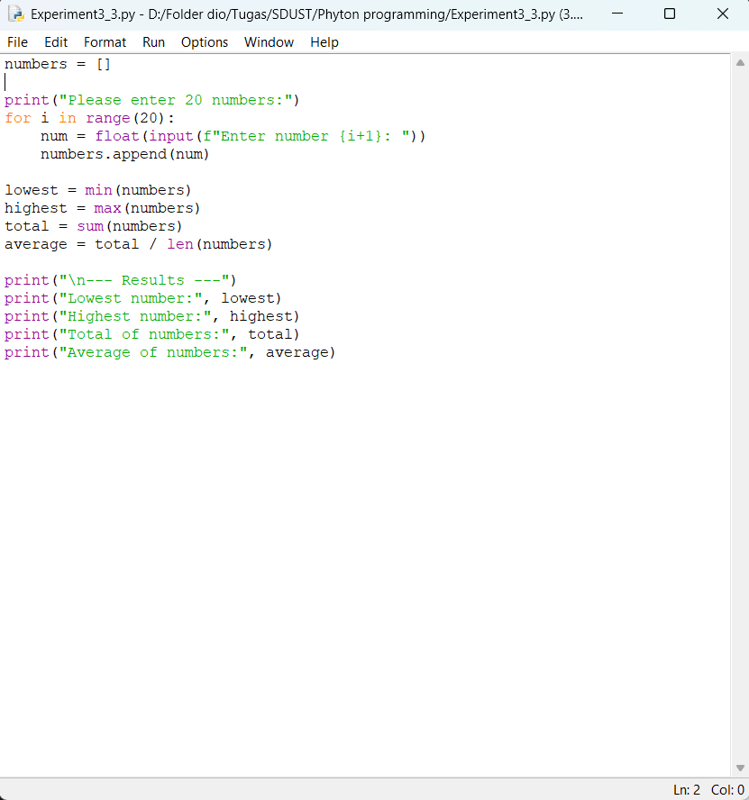
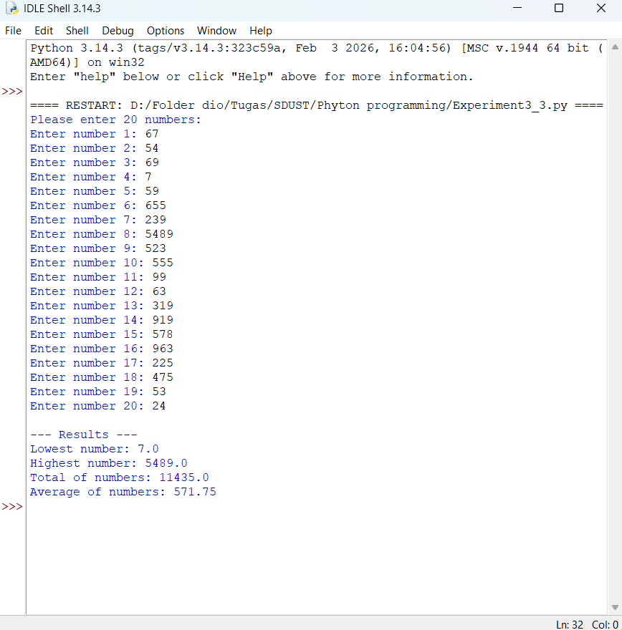

  - Objective3: Series of 20 Numbers

    - Design thought
I plan to create a Python program that has tuple tuple1 = (30, 12, 89, 31, 69, 95), the task is to print the elements with indices from 3 to 5 (inclusive). As far as I'm understanding, in Python, tuple indexing starts at 0, so indices 3, 4, and 5 correspond to the fourth, fifth, and sixth elements respectively. then I used print() function is to display them.
    - Source Code
numbers = []

#input
print("Please enter 20 numbers:") for i in range(20):
num = float(input(f"Enter number {i+1}: ")) numbers.append(num)

lowest = min(numbers) highest = max(numbers) total = sum(numbers)
average = total / len(numbers)

#output
print("\n--- Results ---") print("Lowest number:", lowest) print("Highest number:", highest) print("Total of numbers:", total) print("Average of numbers:", average)
    - Experiment Result

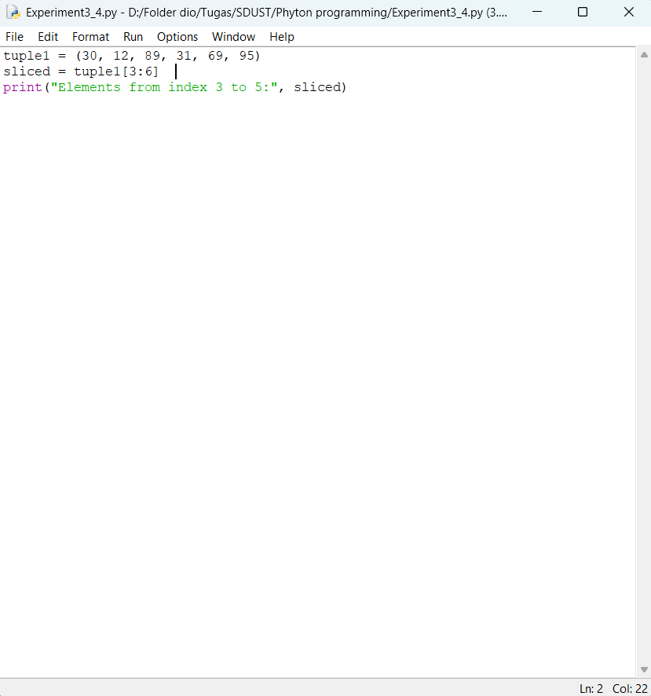
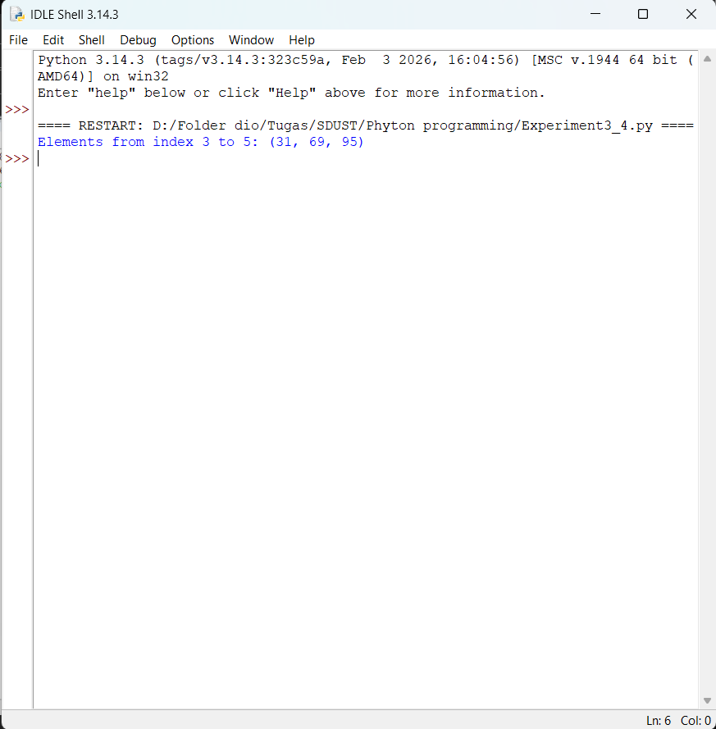
- Experiment Conclusion
What did you learn from the experiment?
From this experiment I learned several important concepts in Python programming. I learned how to use concatenate strings by using the "+" operator to combine first and last names with a space in between. I also learn how to use built-in functions such as

min(), max(), sum(), and len() to compute statistics like the lowest value, highest value, total, and average. Additionally, I learn how to access a range of elements using slicing. Finally, the output formatting to display results clearly with descriptive messages, making the program more user-friendly.

